Computer Networks Lab 02
Name: Hafsa Salman
Roll no. 22K-5161

Question no. 01
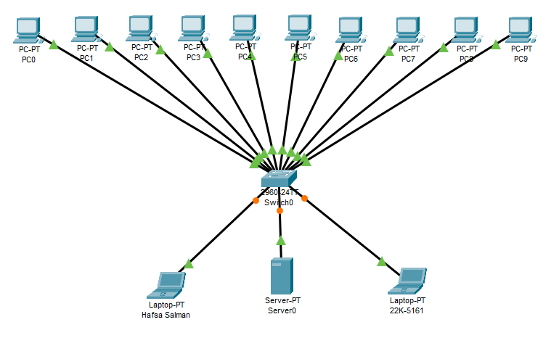

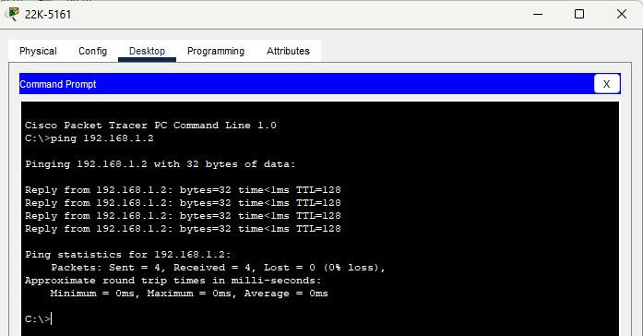
Question no. 02
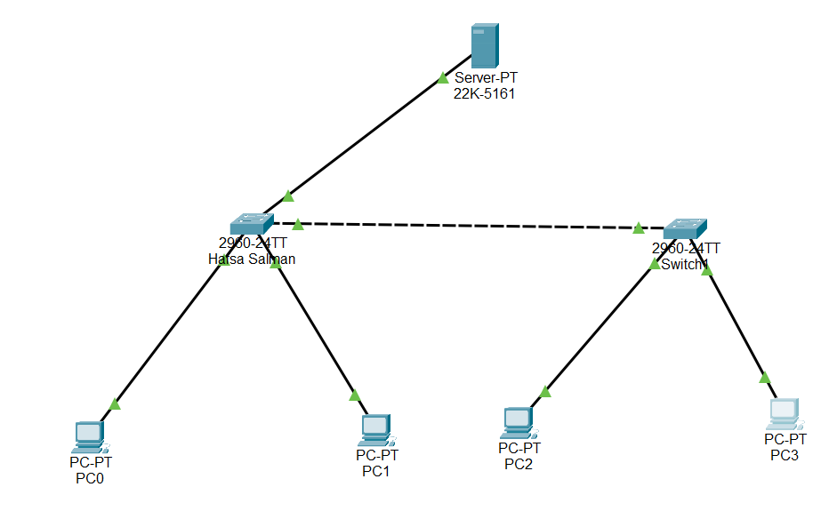
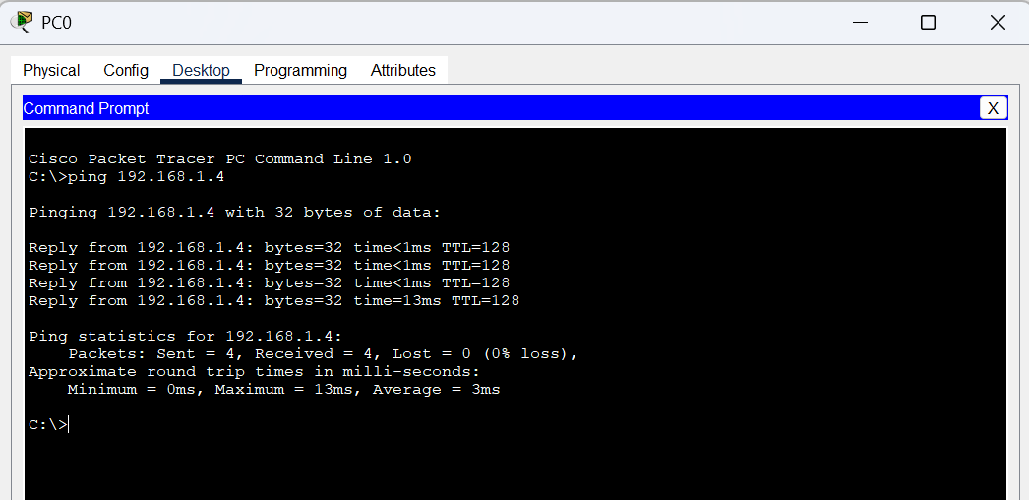
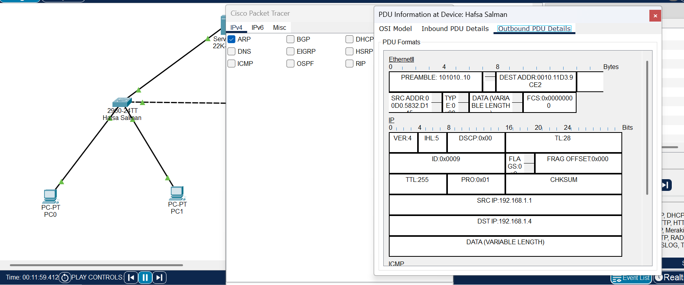
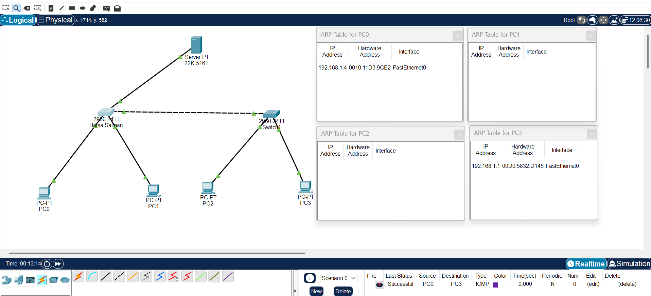

Question no. 03
Part a
Switch | Hub
Switches connect devices to a singular LAN to transmit data from one device to another. | Hubs group Ethernet devices on a LAN, broadcasting all data to all devices.
It can operate on half-duplex and full-duplex communication. | It can operate on half-duplex communication.

Part b
Physical Mode | Logical Mode
Physical mode refers to the transmission of data over physical media. | Logical mode refers to the transmission of data independent of physical connections.
It deals with hardware components. | It deals with protocols, addresses and logical connections.

Part c
Segment 01:
It is a rollover cable that connects PC to Switch. It is used for device configuration via serial console.

Segment 02:
Straight-through cable is used to connect switch to the router. It connects different types of devices with opposite transmission and reception pins.

Segment 03:
Crossover cable is used to connect router to the router. It connects simmer devices by swapping the transmission and reception pins.

Question no. 04
Explanation:
There are 2 hubs. Each hub is connected to a server and 4 PCs. Both hubs are connected to the same bridge. The bridge is dividing the networks into 2 broadcast domains. This means that the broadcasts from the right domain can not reach the left domain and vice versa, unless the broadcast is meant for the other domain.
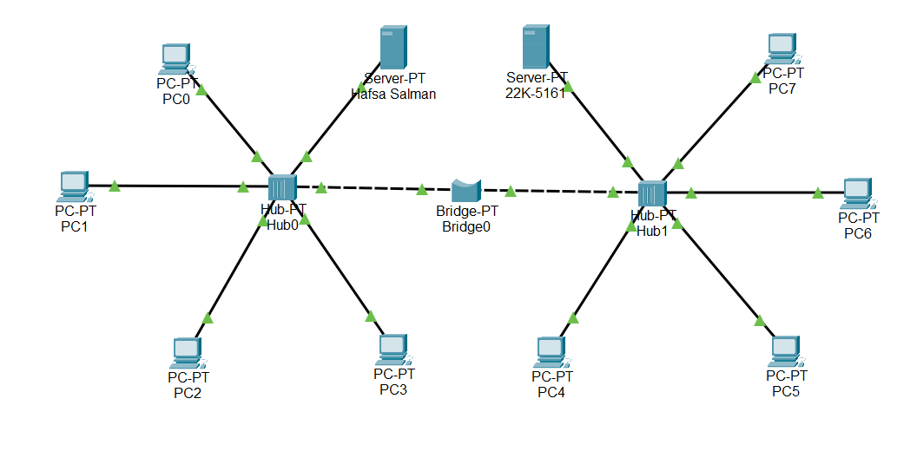
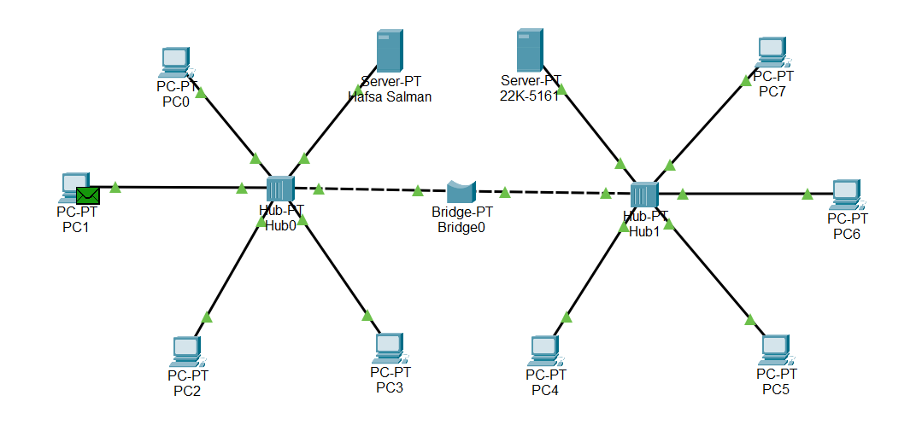
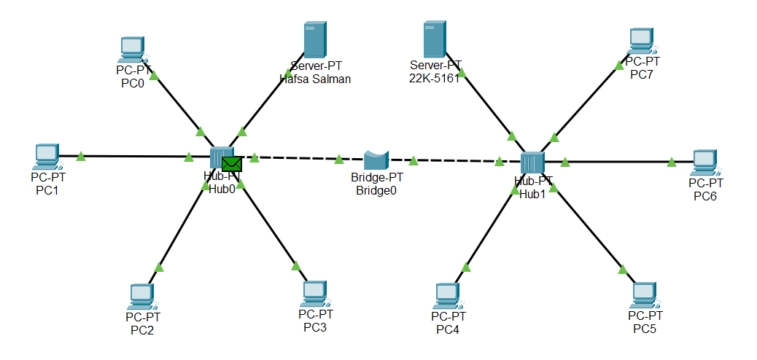
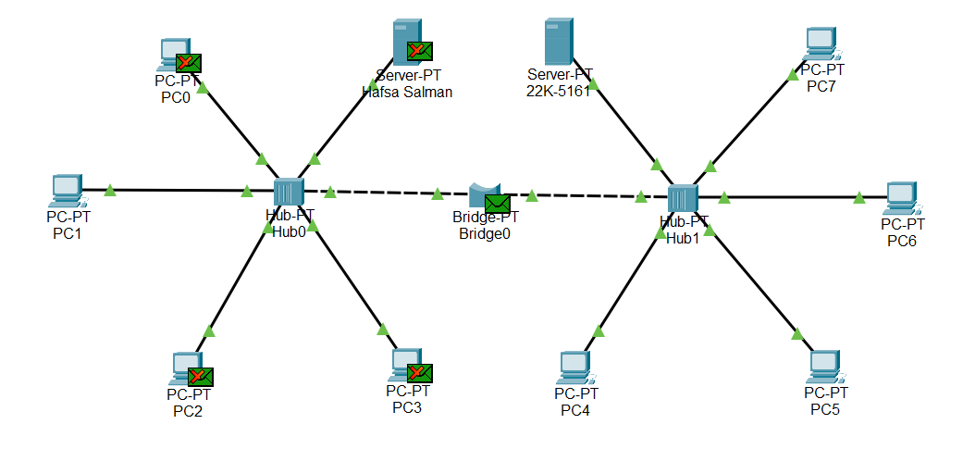
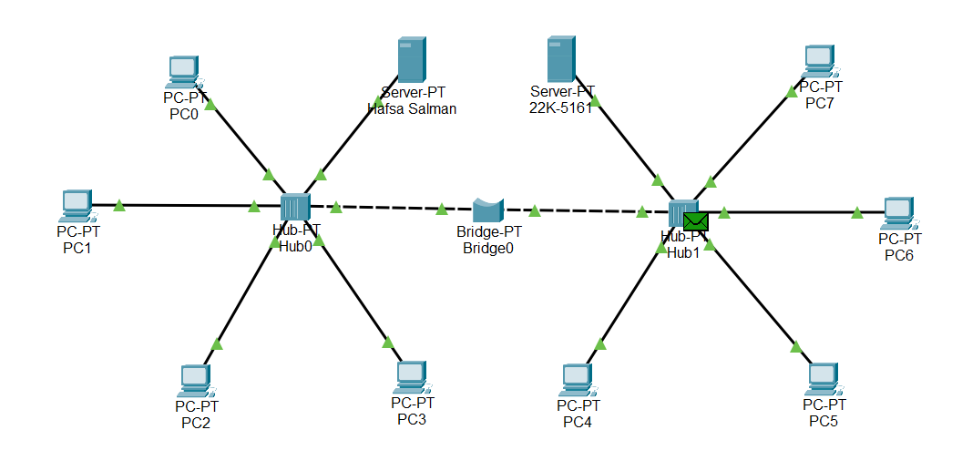
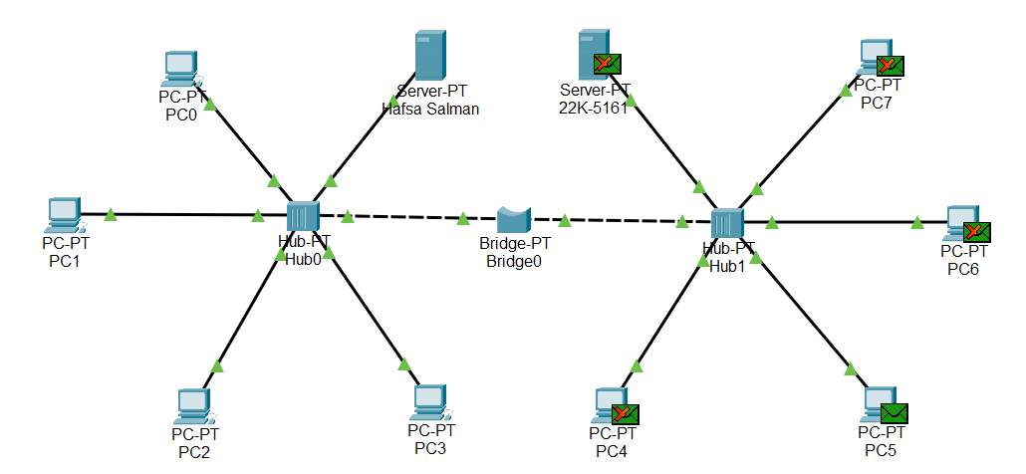
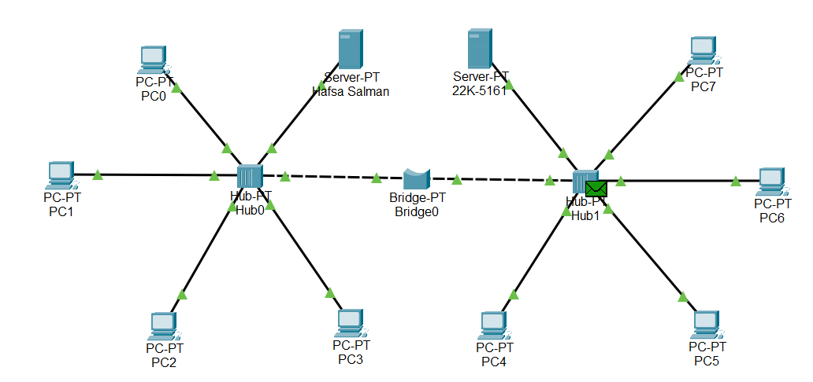
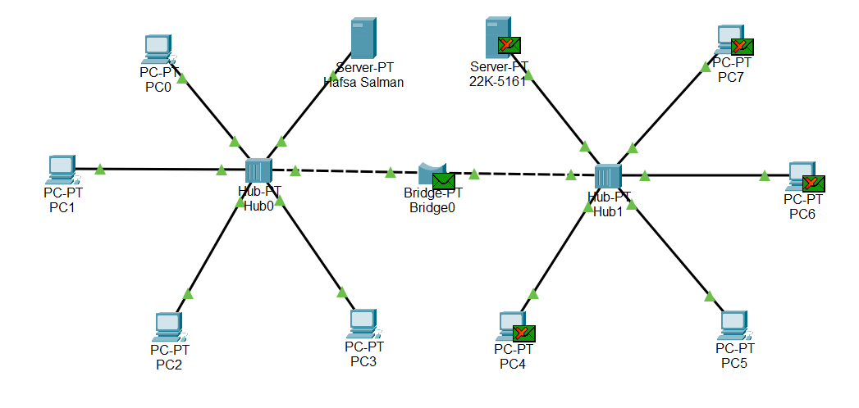
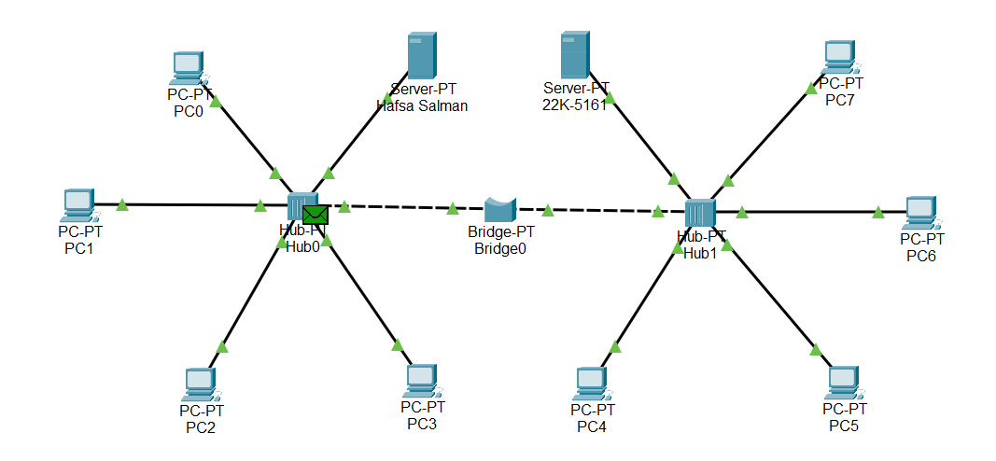
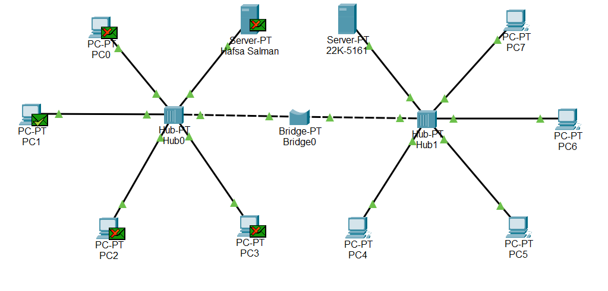


Question no. 05
